**Infosys Resource Configurator – RPA Platform Configuration User Guide (Using Auto Discovery)**

**Version: 1.0**

**Jul-2021**

COPYRIGHT NOTICE

©2021 Infosys Limited, Bangalore, India. All Rights Reserved. Infosys believes the information in this document is accurate as of its publication date; such information is subject to change without notice. Infosys acknowledges the proprietary rights of other companies to the trademarks, product names and such other intellectual property rights mentioned in this document. Except as expressly permitted, neither this documentation nor any part of it may be reproduced, stored in a retrieval system, or transmitted in any form or by any means, electronic, mechanical, printing, photocopying, recording or otherwise, without the prior permission of Infosys Limited and/or any named intellectual property rights holders under this document.

Infosys Limited

Electronic City,

Hosur Road,

Bangalore 560 100

India.

Telephone: 91 80 2852 0261

Fax: 91 80 2852 0362

Website: http://www.infosys.com

Table of Contents

1. Introduction 4

2. Infosys Resource Configurator 5

2.1.1 Auto Configuration 5

2.1.1.1 Auto Configuration for Automation Anywhere Enterprise 6

2.1.1.2 Auto Configuration for UiPath – Community Cloud 10

2.1.1.3 Auto Configuration for UiPath On-Premise 12

2.1.2 Resource 15

2.1.2.1 Automation Anywhere – Resource Model 18

2.1.2.2 UIPath – Resource Model 23

2.1.2.3 Map Resource to Portfolio 26

2.1.2.4 View / Update the Resource Attribute 30

2.1.2.5 Add a new Resource Attribute 37

2.1.2.6 Activate/Deactivate Resources from Resource Screen 40

2.1.2.7 Create a Resource from Resource Screen 45

2.1.2.8 Add/Modify the Monitoring and Remediation Plan 49

2.1.2.9 Activate/Deactivate the Resources 54

3. RPA Control Center 57

3.1.1 RPA Control Center Dashboard 57

# 

# Introduction

This document helps user to create/configure the Resource Model using the Resource Configuration website.

* Auto Discovery
  + Discovery (Auto Configuration) process connects and extracts various details of an RPA platform instance such as the Control Tower, Bot Runners along with its dependencies such as servers, services and database.
  + Once the information is collected it is updated in the Resource Configuration Model store. Note this is a one-time load activity, any subsequent updates to any of the components or their dependencies of the RPA instance will have to be managed from the Resource Configuration screens.
  + This feature is currently supported only for Auto-Discovery of RPA platform components and its dependencies.
* Resource Model
  + A Resource Model defines Entities, its Attributes, and its Relationships with other Entities. For eg: Automation Anywhere has the following Entities and Relationships between the entities are represent in the Figure 1.
    - Control Tower
    - Control Tower Services
    - Database Server
    - Database Services
    - Bot Runner
    - Bot Runner Services
    - Bot Creator
    - Bot Creator Services
    - Bot

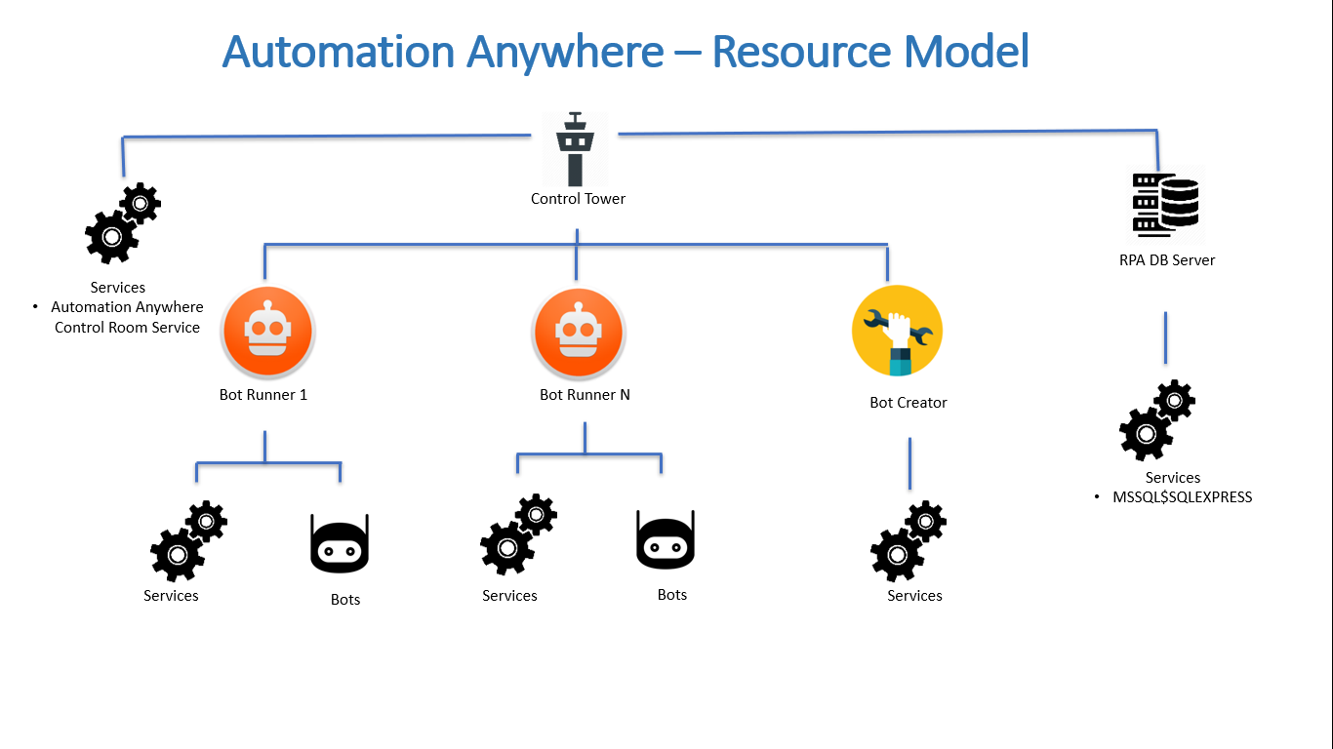

Figure 1

* + In the case of RPA environment configurations, the Resource screen provides a complete Resource Model view of a typical RPA platform instance.
  + It provides a detailed view of all the key Resources such as RPA, IT etc. which constitutes an RPA platform such as Control Tower, Bots, Bot Runners, Servers, Database etc. along with their interdependencies. Each resource will have attributes based on the Resource Type to which resource belongs to.
  + User can review the Resource Model and update the resource attributes, modify the Monitoring & remediation plans.
  + User can Activate/Deactivate any resources.
  + One can also use the Resource Configuration Portal to setup any other types of resources/components such as Databases cluster, End to End Application Stack, Business Processes etc. which can be considered as a Meta model to be used by the target application (Please refer the <<Document>> for how to setup the Resource model without Discovery Process)

# Infosys Resource Configurator

### Auto Configuration

* Open “[http://localhost/configurationmanagementview/home](http://localhost/superbotapp/home)”
* Go the left side panel and Select **Discovery** menuand click **Auto Configuration**.
* In Auto Configuration screen, select any one of the following **Platform Type.**
* Based on the user selection, screen will populate the details according to the selected Platform Type

|  |
| --- |
| **Platform Type** |
| Automation Anywhere Enterprise - 11.3.2.0 |
| UiPath - Community Cloud |
| UiPath On-Premise |

Table

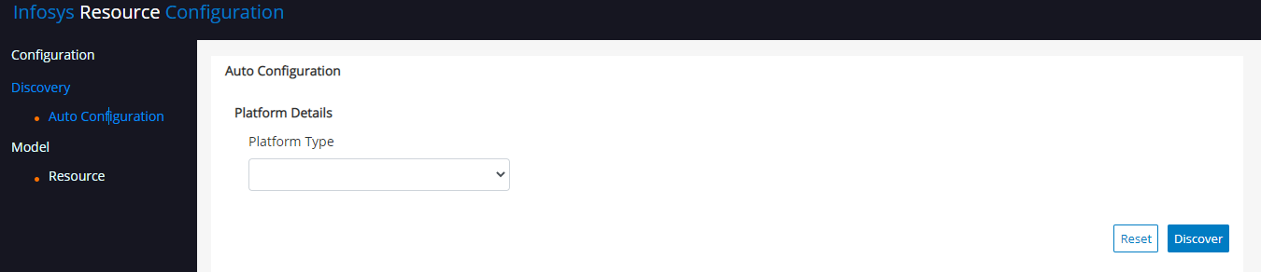

Figure

#### Auto Configuration for Automation Anywhere Enterprise

* If User select **Platform Type** as “Automation Anywhere Enterprise - 11.3.2.0” then “Automation Anywhere Enterprise” specific information will be populated such as Control Tower and Database details as mentioned in Table 2.

(User can get this information from Automation Anywhere Administrator)

|  |  |  |
| --- | --- | --- |
| **Field Name** | **Description** | **Example** |
| Platform Name | <<Enter a Friendly Name of the Platform. The name is an alias which would be used to identify the instance of the platform in an Enterprise>> | DemoAAPlatform |
| Host Name | <<Enter Host Name of the Control Tower Machine which would be used during the monitoring and remediation process>> | VM00001 |
| Control Tower URL | <<Enter Control Tower URL which would be used to access the control tower services for monitoring and remediation process>> | [http//VM00001/](http://vm00001/) |
| Control Tower User Name | <<Enter Control Tower API User Name which would be used for authentication >> (Get the API user name and password from Automation Anywhere Administrator with the following permission   1. Check the device Status 2. Deploy Bot) | Apiuser |
| Control Tower Password | <<Enter Control Tower API Password which would be used for authentication >> | ******* |
| IP Address | <<Enter Control Tower IP Address which would be used during the monitoring and remediation process >> | 10.0.0.1 |
| Service User Name | <<Enter Windows Service Account Name which would be used to execute the monitoring and remediation actions >>  [Service Account with access to run scripts remotely on all RPA components] | DomainName\ServiceUser |
| Service Password | <<Enter Windows Service Account Password which would be used to execute the monitoring and remediation actions >> | ******* |
| Database Host Name | <<Enter Control Tower Database Server Host Name which would be used during the auto configuration, monitoring, and remediation process >> | VM00001 |
| Database Type | <<Select Control Tower Database Type (Currently we are supporting SQL Server>> | SQL Server |
| Database IP Address | <<Enter Control Tower Database Server IP Address which would be used during the monitoring and remediation process >> | 10.0.0.1 |
| Database Name | <<Enter Control Tower Database Name which would be used to connect the Database for Auto Configuration and Monitoring process>> | CRDB-NEW |
| Database User Name | <<Enter Control Tower Database User Name which would be used for database authentication >> with read only permission (Get the Database user name and password from Database administrator) | Appuser |
| Database Password | <<Enter Control Tower Database Password which would be used for database authentication >> | ******* |

Table

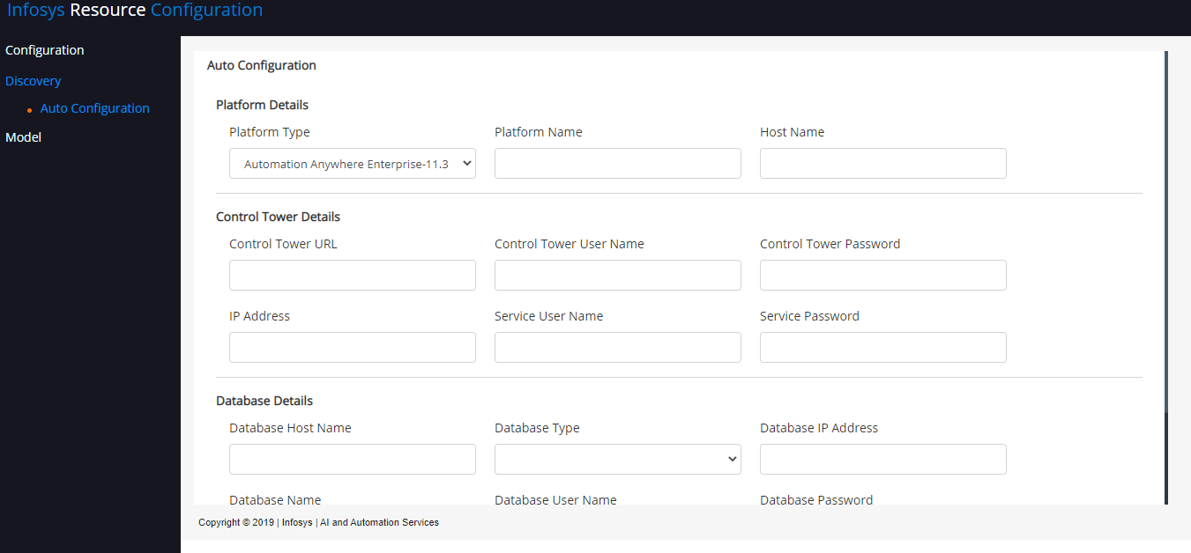

Figure 3

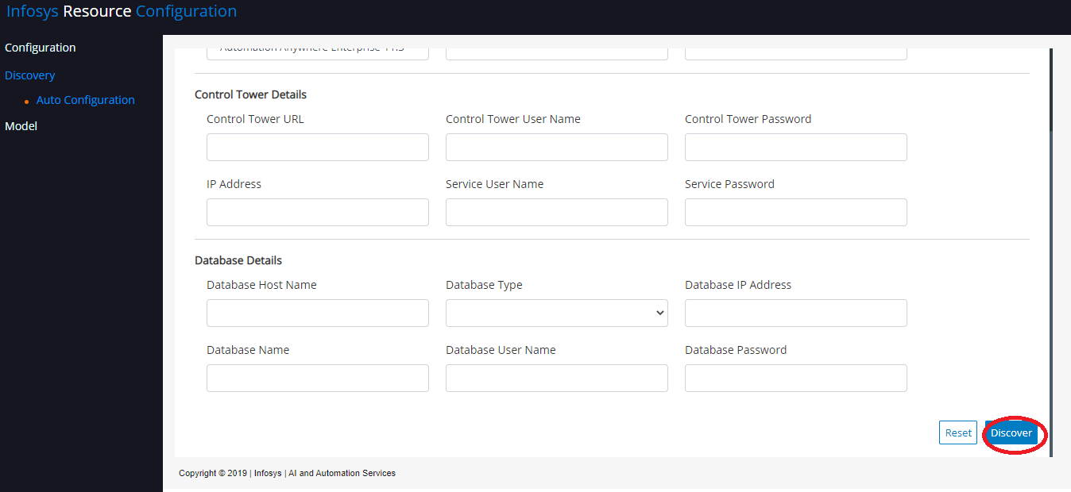

Figure 4

* Fill the details as mentioned in Table 2 and Click on “**Discover**”. After Discovery process, the Resource Model for Automation Anywhere will be created.

#### Auto Configuration for UiPath – Community Cloud

If User select **Platform Type** as “UiPath - Community Cloud” then “UiPath” specific information will be populated such as Orchestrator details as mentioned in Table 3

(User can get this information from UI Path administrator with following permission

* Get Robot and Process details
* Check the device Status, Job Status
* Start Job)

|  |  |  |
| --- | --- | --- |
| **Field Name** | **Description** | **Example** |
| Platform Name | <<Enter a Friendly Name of the Platform. The name is an alias which would be used to identify the instance of the platform in an Enterprise>> | DemoUiPath |
| Orchestrator URL | <<Enter Orchestrator Community Cloud URL which would be used to access the Orchestrator services for Auto Configuration, monitoring, and remediation process>> | [https://cloud.uipath.com](https://cloud.uipath.com/) |
| Authentication URL | <<Enter UiPath Authentication URL which would be used for authentication>> | <https://account.uipath.com/oauth/token> |
| Account Logical Name | <<Enter UiPath Account Logical Name which would be used to construct your unique site URL>> | AccountLogicalName |
| Tenant Logical Name | <<Enter UiPath Tenant Logical Name. The selected service’s logical name. It may differ from the tenant’s name as it is displayed in the Services page>> | TenantLogicalName |
| Client Id | <<Enter UiPath Client Id which would be used for authentication>> | xxxxxxxxxx |
| Refresh Token | <<Enter UiPath Refresh Token which would be used for authentication>> | xxxxxxxxxx |
| UiPath TenantName | << Enter UiPath Tenant Name to call UiPath Services which would be used during the monitoring and remediation process >> | TenantName |

Table

Please refer below mentioned urls for more details: <https://forum.uipath.com/t/how-to-authenticate-to-uipath-cloud-orchestrator-using-api/180188> , <https://docs.uipath.com/orchestrator/v0/reference/consuming-cloud-api>

Figure

* Fill the details as mentioned in Table 3 and Click on “**Discover**”. After Discovery process, Resource Model for UiPath will be created.

#### Auto Configuration for UiPath On-Premise

* If User select **Platform Type** as “UiPath On-Premise” then “UiPath” specific information will be populated such as Orchestrator and Database details as mentioned in Table 4

(User can get this information from UI Path administrator)

|  |  |  |
| --- | --- | --- |
| **Field Name** | **Description** | **Example** |
| Platform Name | <<Enter a Friendly Name of the Platform. The name is an alias which would be used to identify the instance of the platform in an Enterprise>> | DemoUiPath |
| Orchestrator URL | <<Enter Orchestrator URL which would be used to access the Orchestrator services for Auto Configuration, monitoring, and remediation process>> | [http//VM00001/](http://vm00001/) |
| Orchestrator User Name | <<Enter Orchestrator API User Name which would be used for authentication>>  (Get the API username and password from UIPath Administrator with the following permission   1. Get Robot and Process details 2. Check the device Status, Job Status 3. Start Job) | ApiUser |
| Orchestrator Password | <<Enter Orchestrator API Password which would be used for authentication >> | ********** |
| IP Address | <<Enter Orchestrator IP Address which would be used during the monitoring and remediation process>> | 10.0.0.1 |
| Service User Name | <<Enter Windows Service Account Name which would be used to execute the monitoring and remediation actions>>  [Service Account with access to run scripts remotely on all RPA components] | DomainName\ServiceUser |
| Service Password | <<Enter Windows Service Account Password which would be used to execute the monitoring and remediation actions>> | ******* |
| Authentication URL | <<Enter Orchestrator Authentication URL which would be used for authentication>> | [https://VM00001/api/account/authenticate](https://vm00001/api/account/authenticate) |
| UiPath Tenant Name | << Enter UiPath Tenant Name to call UiPath Services which would be used during the monitoring and remediation process >> | Default |
| Database Host Name | <<Enter Orchestrator Database Server Host Name which would be used during the monitoring, and remediation process >> | VM00001 |
| Database Type | <<Select Orchestrator Database Type, currently we are supporting SQL Server>> | SQL Server |
| Database IP Address | <<Enter Orchestrator Database Server IP Address which would be used during the monitoring and remediation process>> | 10.0.0.1 |
| Database Name | <<Enter Orchestrator Database Name which would be used to connect the Database for monitoring purpose>> | UiPath |
| Database User Name | <<Enter Orchestrator Database User Name for authentication>> with read only permission (Get the Database user name and password from Database administrator) | Appuser |
| Database Password | <<Enter Orchestrator Database Password for authentication>> | ******* |

Table

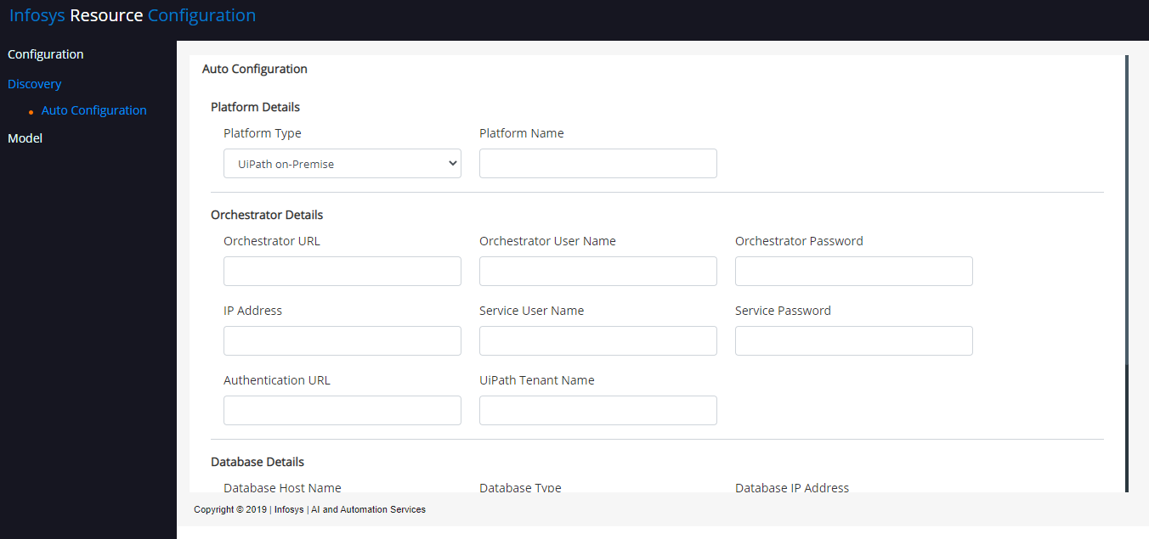

Figure

Figure

* Fill the details as mentioned in Table 4 and Click on “**Discover**”. After Discovery process, Resource Model for UiPath will be created.

### Resource

* Open “http://localhost/configurationmanagementview/home”
* Go the left side panel and Select **Model** Menuand click **Resource**.
* In Platform Details screen,
  + User can select any of the platform instance and click “Edit” icon to View/Edit Resource Model
  + User can select any of the platform instance and click “Activate/Deactivate” button to Activate/Deactivate of the Resources

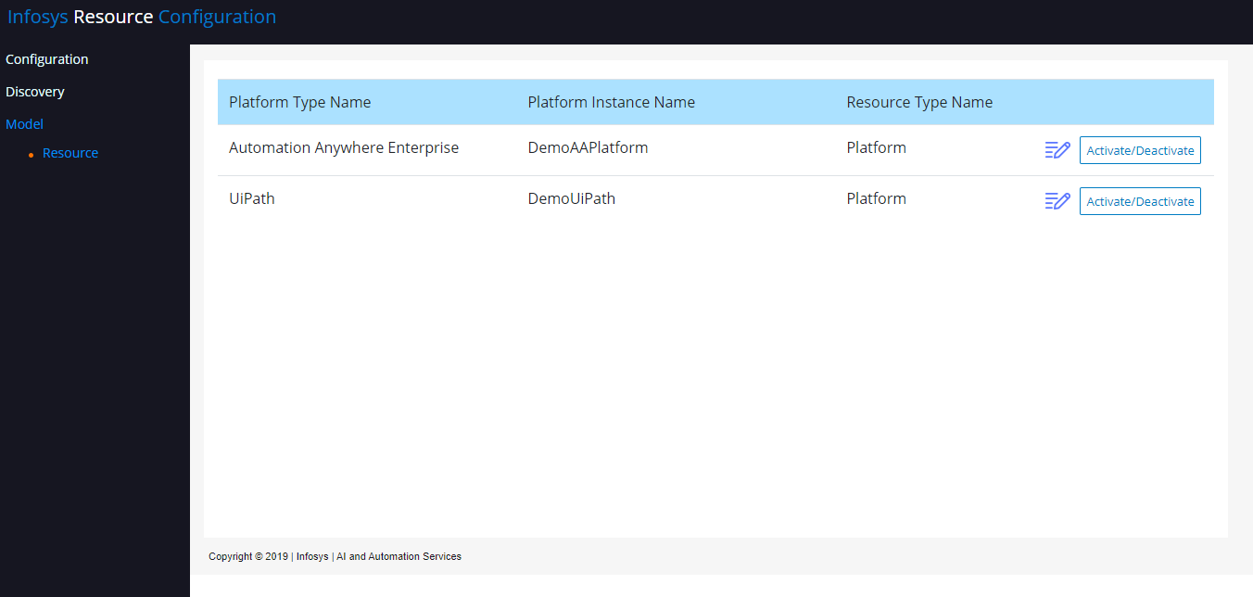

Figure

* The Key components/Fields of the Resource Models are given below in the Table 5 and Figure 9 & 10

|  |  |
| --- | --- |
| **Key Components** | **Description** |
| Resource Type | Type of RPA Components such as Control Tower, Bot Runner, Bot, Data Base Server etc., |
| Resources | Actual instance/Component/Process etc.  For example:  Control Tower Instance Name: VM00001  Bot Name: AccountReconcilation.atmx |
| Validity Period | Validity Start Date, Validity End Date of the resource |
| Activate / Deactivate | Enable / Disable the resources for monitoring |
| Portfolio | Under which Portfolio the resource should be displayed in RPA control center dashboard |
| Monitoring Plan /Remediation Plan | User can define more than one Monitoring and remediation plan for a resource. Based this rule system will perform the monitoring and remediation process f |
| Parameters | Parameter values are used in the monitoring or remediation process |

Table

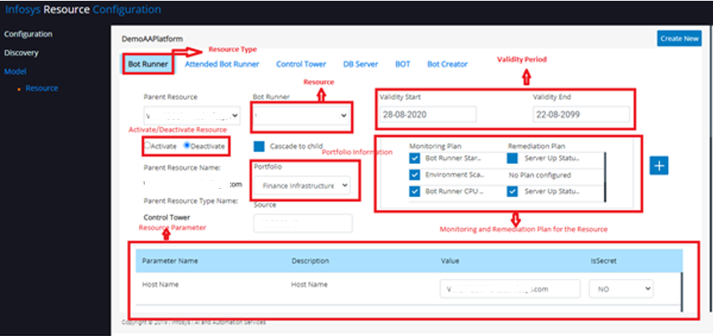

Figure

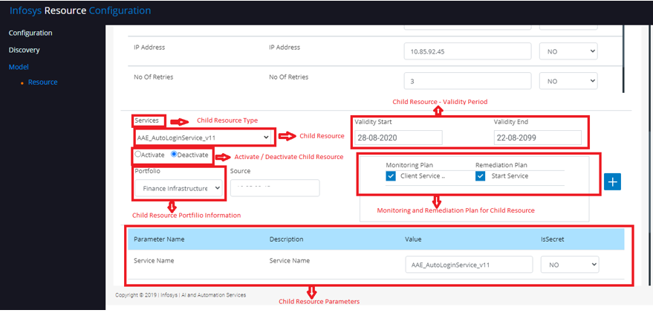

Figure

* If user wants to view/modify a Resource Model for a platform, then click “Edit” icon of the Platform
* For Example, If user wants to view/modify “DemoAAPlatform” platform, then click “Edit” icon as mentioned in the Figure 11

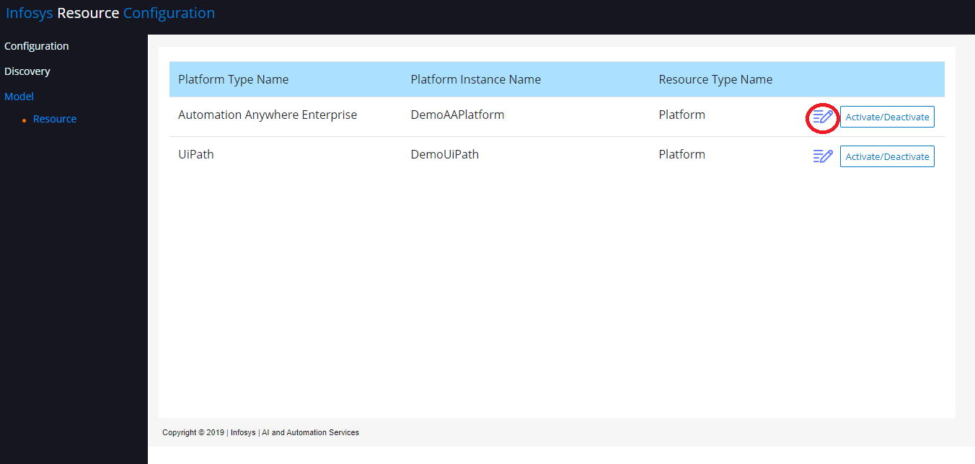

Figure

* User can view/modify the portfolio, resource parameters, monitoring plan, remediation plan and activate/deactivate any resources from the Resource screen

#### Automation Anywhere – Resource Model

* If the Platform Type is “Automation Anywhere”, then Resource Screen has the following Tab as mentioned in the Figure 9

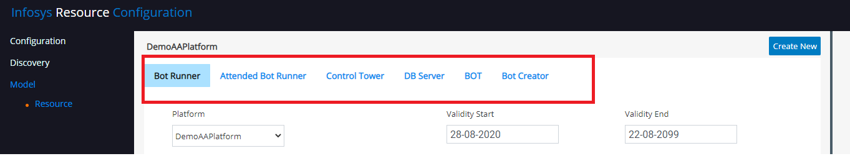

Figure

* Sample Control Tower Resource details are mentioned in the Table 5, and its child resource details are mentioned in the Table 6,7

|  |  |
| --- | --- |
| Resource Type | Control Tower |
| Resource Name | VM000001 |
| Number of Resources | 1 (If AA has more than 1 control tower, we must create separate platform instance for each Control tower) |
| Metric Name | Server Status |
| Monitoring Plan | Control Room Stopped |
| Remediation Plan | Server Up Status Check |
| Child Resource Type | Services |

Table

* There are 13 Control Tower services are available and details are given below in Table 7

|  |
| --- |
| **Control Tower service** |
| Automation Anywhere Control Room Service |
| Automation Anywhere Elastic Search Service |
| Automation Anywhere Control Room Reverse Proxy |
| Automation Anywhere Control Room Messaging |
| Automation Anywhere Control Room Caching |
| Automation Anywhere Bot Insight Visualization |
| Automation Anywhere Bot Insight Service Discovery |
| Automation Anywhere Bot Insight Service |
| Automation Anywhere Bot Insight Scheduler |
| Automation Anywhere Bot Insight Query Engine |
| Automation Anywhere Bot Insight Elastic Search |
| Automation Anywhere Bot Insight EDC |
| Automation Anywhere Licensing |

Table

|  |  |
| --- | --- |
| Resource Type | Services |
| Resource Name | <<Each Control Tower Service Name>> |
| Number of Resources | 13 |
| Metric Name | Service Status |
| Monitoring Plan | Client Service Status Check |
| Remediation Plan | Start Service |

Table

* Sample Bot Runner Resource details are mentioned in the Table 9, and its child details are mentioned in the Table 10,11

|  |  |
| --- | --- |
| Resource Type | Bot Runner |
| Resource Name | VM000002 |
| Number of Resources | N (We can have “N” of Bot Runner attach to the Control Tower, dependence upon the AA license) |
| Metric Name | Server Status |
| Monitoring Plan | Bot Runner Start |
| Remediation Plan | Server Up Status Check |
| Child Resource Type | Services |

Table

* There are 3 Bot Runner services are available and details are given below in Table 10

|  |
| --- |
| **Bot Runner Services** |
| AAE_AutoLoginService_v11 |
| AAE_SchedulerService_v11 |
| AAE_ClientService_v11 |

Table

|  |  |
| --- | --- |
| Resource Type | Services |
| Resource Name | <<Each Bot Runner Service Name>> |
| Number of Resources | 3 |
| Metric Name | Service Status |
| Monitoring Plan | Client Service Status Check |
| Remediation Plan | Start Service |

Table

* Sample Attended - Bot Runner Resource details are mentioned in the Table 12, and its child details are mentioned in the Table 13,14

|  |  |
| --- | --- |
| Resource Type | Attended Bot Runner |
| Resource Name | VM000003 |
| Number of Resources | N (We can have “N” of Attended Bot Runner attach to the Control Tower, dependence upon the AA license) |
| Metric Name | Server Status |
| Monitoring Plan | Attended Bot Runner Status Check |
| Remediation Plan | Server Up Status Check |
| Child Resource Type | Services |

Table

* There are 3 Attended Bot Runner services are available and details are given below in Table 13

|  |
| --- |
| **Attended Bot Runner Services** |
| AAE_AutoLoginService_v11 |
| AAE_SchedulerService_v11 |
| AAE_ClientService_v11 |

Table

|  |  |
| --- | --- |
| Resource Type | Services |
| Resource Name | <<Each Attended Bot Runner Service Name>> |
| Number of Resources | 3 |
| Metric Name | Service Status |
| Monitoring Plan | Client Service Status Check |
| Remediation Plan | Start Service |

Table

* Sample Bot Creator Resource details are mentioned in the Table 15, and its child details are mentioned in the Table 16,17

|  |  |
| --- | --- |
| Resource Type | Bot Creator |
| Resource Name | VM000005 |
| Number of Resources | N (We can have “N” of Bot Creator attach to the Control Tower, dependence upon the AA license) |
| Metric Name | Server Status |
| Monitoring Plan | Bot Creator Start |
| Remediation Plan | Server Up Status Check |
| Child Resource Type | Services |

Table

* There are 3 Bot Creator services are available and details are given below in Table 16

|  |
| --- |
| **Bot Creator Services** |
| AAE_AutoLoginService_v11 |
| AAE_SchedulerService_v11 |
| AAE_ClientService_v11 |

Table

|  |  |
| --- | --- |
| Resource Type | Services |
| Resource Name | <<Each Bot Creator Service Name>> |
| Number of Resources | 3 |
| Metric Name | Service Status |
| Monitoring Plan | Client Service Status Check |
| Remediation Plan | Start Service |

Table

* Sample Database Server Resource details are mentioned in the Table 18, and its child details are mentioned in the Table 19,20

|  |  |
| --- | --- |
| Resource Type | DB Server |
| Resource Name | VM000001 |
| Number of Resources | 1 |
| Metric Name | Server Status |
| Monitoring Plan | DB Server Status Check |
| Remediation Plan | Server Up Status Check |
| Child Resource Type | DB Service |

Table

* There is 1 DB Service is available and detail is given below in Table 19

|  |
| --- |
| **DB Services** |
| MSSQLSERVER |

Table

|  |  |
| --- | --- |
| Resource Type | DB Service |
| Resource Name | <<Each DB Service Name>> |
| Number of Resources | 1 |
| Metric Name | Service Status |
| Monitoring Plan | Client Service Status Check |
| Remediation Plan | Start Service |

Table

* Sample BOT Resource details are mentioned in the Table 21

|  |  |
| --- | --- |
| Resource Type | BOT |
| Resource Name | <<Actual Bot Name>> |
| Number of Resources | N |
| Metric Name | Bot Status |
| Monitoring Plan | Bot Check Status |
| Remediation Plan | Start Bot |

Table

#### UIPath – Resource Model

* If the Platform Type is “UiPath”, then Resource Screen has the following Tab as mentioned in the Figure 13

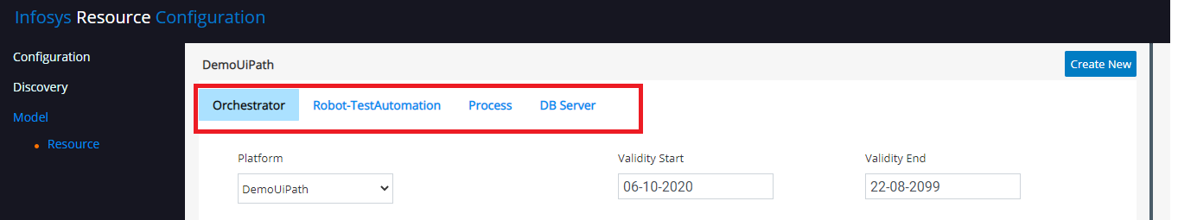

Figure

* Sample Orchestrator details are mentioned in the Table 22

|  |  |
| --- | --- |
| Resource Type | Orchestrator |
| Resource Name | VM000001 |
| Number of Resources | 1 (If UiPath has more than 1 Orchestrator, then we must create separate platform instance for each Orchestrator) |
| Metric Name | Server Status |
| Monitoring Plan | RPA Orchestrator Monitor |
| Remediation Plan | Orchestrator Remediation |

Table

* Sample Robot Resource details are mentioned in the Table 23, and its child details are mentioned in Table 24,25

|  |  |
| --- | --- |
| Resource Type | Robot |
| Resource Name | VM000002 |
| Number of Resources | N (We can have “N” of Robot attach to the Orchestrator, dependence upon the UiPath license) |
| Metric Name | Server Status |
| Monitoring Plan | Robot Status |
| Remediation Plan | Server Up Status Check |
| Child Resource Type | Services |

Table

* There are 2 Robot services are available and details are given below in Table 7

|  |
| --- |
| **Robot service** |
| UiRobotSvc |
| UiPath RobotJS Service |

Table

|  |  |
| --- | --- |
| Resource Type | Services |
| Resource Name | <<Each Robot Service Name>> |
| Number of Resources | 2 |
| Metric Name | Service Status |
| Monitoring Plan | Service Status |
| Remediation Plan | Start Service |

Table

* Sample Process Resource details are mentioned in the Table 26

|  |  |
| --- | --- |
| Resource Type | Process |
| Resource Name | <<Actual Process Name>> |
| Number of Resources | N |
| Metric Name | Bot Status |
| Monitoring Plan | Process Status |
| Remediation Plan | Start Job for Process |

Table

* Sample DB Server Resource details are mentioned in the Table 27, and its child details are mentioned in the Table 28,29

|  |  |
| --- | --- |
| Resource Type | DB Server |
| Resource Name | VM000001 |
| Number of Resources | 1 |
| Metric Name | Server Status |
| Monitoring Plan | DB Server Status Check |
| Remediation Plan | Server Up Status Check |
| Child Resource Type | Services |

Table

* 1 DB service is available, and detail is given below in Table 28

|  |
| --- |
| **Robot service** |
| MSSQLSERVER |

Table

|  |  |
| --- | --- |
| Resource Type | Services |
| Resource Name | <<Each Database Service Name>> |
| Number of Resources | 1 |
| Metric Name | Service Status |
| Monitoring Plan | Service Status |
| Remediation Plan | Start Service |

Table

#### Map Resource to Portfolio

* By default, all the Resources are mapped to Default Portfolio.
* If User wants to create a new portfolio, please refer “Create Portfolio” Section in SuperBot_Installation_Document.docs
* After creating the desired portfolio, user can Map the Portfolio using Resource screen

For Example,

The user created the following Portfolios

1. Finance Infrastructure
   * For all the Infrastructure components such as Control Tower, Control Tower Windows Service, Bot Runner, Bot Runner Windows Services, Database Server, Database windows services, Bot Creator, Bot Creator windows Services.
2. Finance Business Process
   * For all the Bot / Process, example: Account Reconciliation Bot, Order Entry Bot, Order Processing Bot, Worker Order Bot
   * If Users wants to map “Finance Infrastructure” Portfolio to Control Tower instance and it services, then perform the following steps
     1. Click Edit icon of the platform as mentioned in the Figure 14, it will open the Resource model of Automation Anywhere Enterprise (DemoAAPlatform)



Figure

* + 1. Click “Control Tower” tab and choose the “Finance Infrastructure” Portfolio as mentioned in the Figure 15.

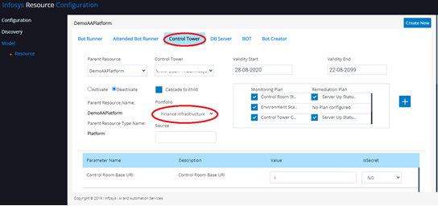

Figure

* + 1. Scroll down and select the Control Tower windows Service and choose “Finance Infrastructure” Portfolio as mentioned in the Figure 16.

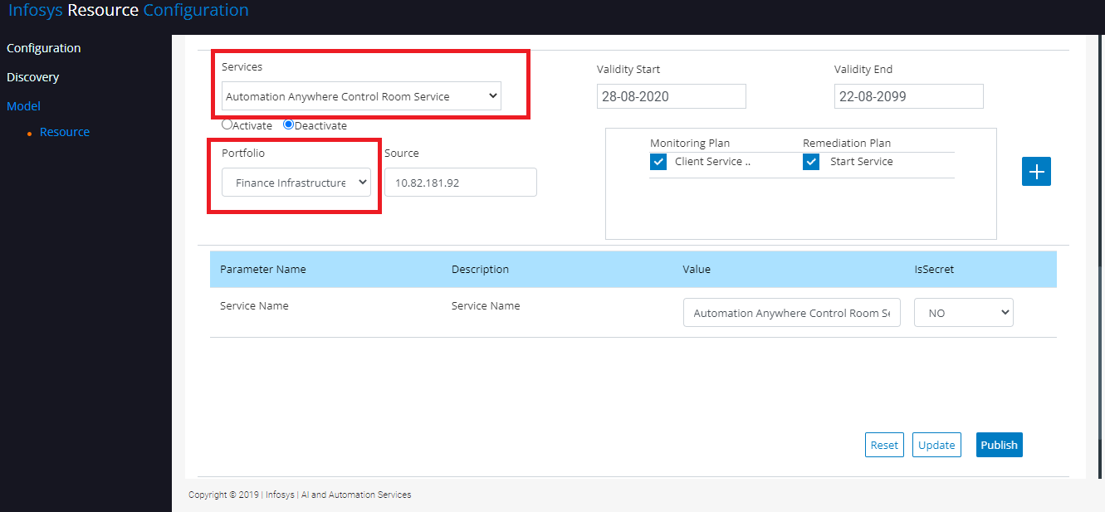

Figure

* + 1. Click “Update” button to Save the changes as mentioned in the Figure 17
    2. User has to choose all the Control Tower windows services one by one and perform step **c** and **d** for all services.

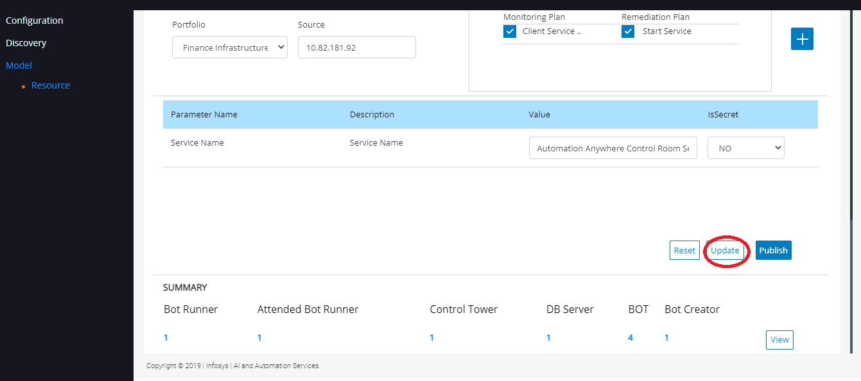

Figure

* + If Users wants to map “Finance Infrastructure” Portfolio for other infrastructure components such as “Bot Runner, Bot Creator, Database Server and Attend Bot Runner” perform the above steps from **a** to **e** (In step **b** choose desired component tab)
  + If Users wants to map “Finance Business Process” Portfolio for Account Reconciliation Bot, then perform the following steps
    1. Click Edit icon of that platform as mentioned in the Figure 18, it will open the Resource model of Automation Anywhere Enterprise (DemoAAPlatform)



Figure

* + 1. Click “Bot” tab and Select the “Account Reconciliation” Bot and choose “Finance Business Process” Portfolio as mentioned in the Figure 19

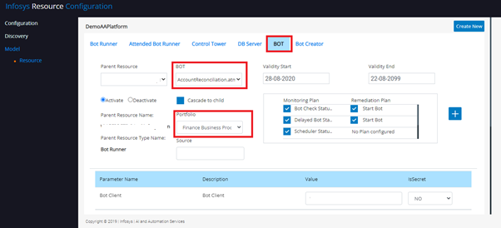

Figure

* + 1. Click “Update” button to Save changes as mentioned in the Figure 20

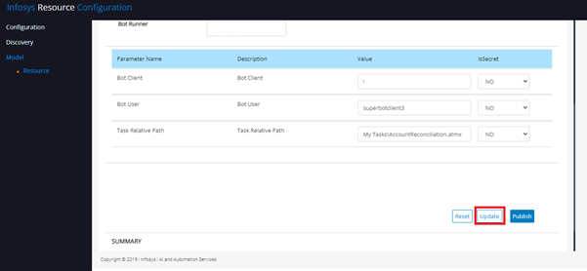

Figure

* + User has to choose all other Bot one by one and perform step **f** and **h** for other Bots.

#### View / Update the Resource Attribute

* User can view and modify the parameter details of any resource via Resource screen. Resource attributes are used in the monitoring or remediation process. Most of the Resource attributes are populated as part of Auto Discovery process.
* Resource attribute section contains the following fields as mentioned in the Figure 21
  + Parameter Name
    - Name of the Attribute
  + Description
    - Description of the Attribute
  + Value
    - Value of the Attribute
  + IsSecret
    - Yes/No value. In case of password this field should be Yes.
    - If Yes, the value will be stored as an encrypted format in the Database.

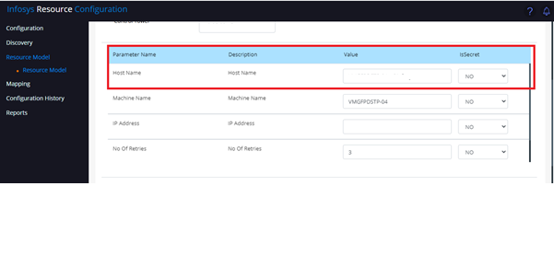

Figure

##### **Automation Anywhere – Resource Attribute details**

* Sample Control Tower attribute details are given below in the Table 30

|  |  |  |  |
| --- | --- | --- | --- |
| **Parameter Name** | **Description** | **Value** | **IsSecret** |
| Control Room Base URI | Control Room Base URI which would be used to access the control tower services for monitoring and remediation process | http//VM00001/ | No |
| Control Room Password | Control Room Password which would be used for authentication | ******* | Yes |
| Control Room User Name | Control Room User Name which would be used for authentication | Apiuser | No |
| Host Name | Control Tower Host Name which would be used during the monitoring and remediation process | VM00001 | No |
| Machine Name | Control Tower Host Name which would be used during the monitoring and remediation process | VM00001 | No |
| IP Address | Control Tower IP Address which would be used during the monitoring and remediation process | 10.0.0.1 | No |
| No Of Retries | Number of Retries which would be used during the monitoring process | 3 | No |
| Wait Time | Wait Time (In second) which would be used during the monitoring process | 30 | No |

Table

**Note:**

No Of Retries, Wait Time: parameters are used during the monitoring process.

For example: Host Name = VM00001, No Of Retries = 3 and Wait Time = 30

System tries to access (ping) the VM0001, if not able to access it will wait for 30 second and retires up to 3 time. If System not able access after 3 times. System detected as “Anomaly” and perform the remediation process.

* Sample Bot Runner, Attended Bot Runner, Bot Creator attribute details are given below in the Table 31

|  |  |  |  |
| --- | --- | --- | --- |
| **Parameter Name** | **Description** | **Value** | **IsSecret** |
| Host Name | Host Name of the VM which would be used during the monitoring and remediation process | VM00002 | No |
| Machine Name | Machine Name of the VM which would be used during the monitoring and remediation process | VM00002 | No |
| IP Address | IP Address Name of the VM which would be used during the monitoring and remediation process | 10.0.0.2 | No |
| No Of Retries | Number of Retries which would be used during the monitoring process | 3 | No |
| Wait Time | Wait Time (In second) which would be used during the monitoring process | 30 | No |

Table

* Sample Database Server attribute details are given below in the Table 32

|  |  |  |  |
| --- | --- | --- | --- |
| **Parameter Name** | **Description** | **Value** | **IsSecret** |
| Host Name | Host Name of the VM which would be used during the monitoring and remediation process | VM00001 | No |
| Input | Host Name of the VM which would be used during the monitoring and remediation process | VM00001 | No |
| Machine Name | IP Address of the VM which would be used during the monitoring and remediation process | 10.0.0.1 | No |
| IP Address | IP Address of the VM which would be used during the monitoring and remediation process | 10.0.0.1 | No |
| No Of Retries | Number of Retries which would be used during the monitoring process | 3 | No |
| Wait Time | Wait Time (In second) which would be used during the monitoring process | 30 | No |

Table

* Sample Bot attribute details are given below in the Table 33

|  |  |  |  |
| --- | --- | --- | --- |
| **Parameter Name** | **Description** | **Value** | **IsSecret** |
| Bot Client | Bot Runner Name which would be used during the monitoring and remediation process | VM00002 | No |
| Bot User | Automation Anywhere Client login username which would be used during the monitoring and remediation process | Botclientuser | No |
| Task Relative Path | Bot Task Relative Path which would be used during the monitoring and remediation process | My Tasks\AccountReconciliation.atmx | No |

Table

* Sample Service (Control Tower Services, Bot Runner Services, Attended Bot Runner Services, Bot Creator Services, Database Services) attribute details are given below in the Table 34

|  |  |  |  |
| --- | --- | --- | --- |
| **Parameter Name** | **Description** | **Value** | **IsSecret** |
| Service Name | Service Name of the Automation Anywhere components (Control Tower Services, Bot Runner Services, Attended Bot Runner Services, Bot Creator Services, Database Services) which would be used during the monitoring and remediation process | Automation Anywhere Control Room Service | No |

Table

##### **UiPath – Resource Attribute details**

* Sample Orchestrator attribute details are given below in the Table 35

|  |  |  |  |
| --- | --- | --- | --- |
| **Parameter Name** | **Description** | **Value** | **IsSecret** |
| Authentication URI | UiPath Authentication URL which would be used for authentication | [https://VM00001/api/account/authenticate](https://vm00001/api/account/authenticate) | No |
| Client Id | Client Id to Generate API token which would be used for authentication |  | No |
| Device Service URI | UiPath Service to check the Device Status which would be used during the monitoring process | [https://VM00001/odata/Sessions](https://vm00001/odata/Sessions) | No |
| IP Address | Orchestrator IP Address which would be used during the monitoring and remediation process | 10.0.0.1 | No |
| Job Status Service URI | UiPath Service to check the Device Status which would be used during the monitoring process | [https://VM00001/odata/Jobs](https://vm00001/odata/Jobs) | No |
| Password | Orchestrator API Password which would be used for authentication | ******** | Yes |
| Refresh token | Refresh Token to generate API token which would be used for authentication |  | No |
| Service Password | Windows Service Account Password which would be used to execute the monitoring and remediation actions | ******** | Yes |
| Service User Name | Windows Service Account User Name which would be used to execute the monitoring and remediation actions | DomainName\ServiceUser | No |
| Start Job Service URI | UiPath Service to Start the Job which would be used during the remediation process | [https://VM00001/odata/Jobs/UiPath.Server.Configuration.OData.StartJobs](https://vm00001/odata/Jobs/UiPath.Server.Configuration.OData.StartJobs) | No |
| UiPath Tenant Name | UiPath Tenant Name to call UiPath Services which would be used during the monitoring and remediation process | Default | No |
| User Name | Orchestrator API User Name which would be used for authentication | ApiUser | No |

Table

Note: Client Id, Refresh token are used in UiPath – Community Cloud.

* Sample Robot, Robot-Attended attribute details are given below in the Table 36

|  |  |  |  |
| --- | --- | --- | --- |
| **Parameter Name** | **Description** | **Value** | **IsSecret** |
| Machine Name | Host Name of the Robot VM which would be used during the monitoring and remediation process | VM00001 | No |
| No Of Retries | Number of Retries which would be used during the monitoring process | 3 | No |
| UiPath Robot Id | UiPath Robot Id which would be used during the monitoring and remediation process | 7 | No |
| Wait Time | Wait Time (In second) which would be used during the monitoring process | 30 | No |

Table

* Sample Process attribute details are given below in the Table 37

|  |  |  |  |
| --- | --- | --- | --- |
| **Parameter Name** | **Description** | **Value** | **IsSecret** |
| Process Release Key | Release Key of the UiPath Process which would be used during the monitoring and remediation process | d3c016cd-89b9-4914-8542-973776ac3f65 | No |
| Process Release Name | Release Name of the UiPath Process which would be used during the monitoring and remediation process | InboundTransportation | No |

Table

* Sample Service (Robot Services, Robot-Attended Services, Database Services) attribute details are given below in the Table 38

|  |  |  |  |
| --- | --- | --- | --- |
| **Parameter Name** | **Description** | **Value** | **IsSecret** |
| Service Name | Service Name UiPath Components (Robot Services, Robot-Attended Services, Database Services) which would be used during the monitoring and remediation process | UiRobotSvc | No |

Table

* Sample Database Server attribute details are given below in the Table 39

|  |  |  |  |
| --- | --- | --- | --- |
| **Parameter Name** | **Description** | **Value** | **IsSecret** |
| Host Name | Host Name of the Database server which would be used during the monitoring and remediation process | VM00001 | No |
| Input | Host Name of the Database server which would be used during the monitoring and remediation process | VM00001 | No |
| Machine Name | IP Address of the Database server which would be used during the monitoring and remediation process | 10.0.0.1 | No |
| IP Address | IP Address of the Database server which would be used during the monitoring and remediation process | 10.0.0.1 | No |
| No Of Retries | Number of Retries which would be used during the monitoring process | 3 | No |
| Wait Time | Wait Time (In second) which would be used during the monitoring process | 30 | No |

Table

**Note:**

No Of Retries, Wait Time: parameters are used during the monitoring process.

For example: Host Name = VM00001, No Of Retries = 3 and Wait Time = 30

System tries to access (ping) the VM0001, if not able to access it will wait for 30 second and retires up to 3 time. If System not able access after 3 times. System detected as “Anomaly” and perform the remediation process.

#### Add a new Resource Attribute

* In case if user wants to add a new parameter, then user can add it from Resource screen

**Note**: All the required parameters are created automatically in Auto Discovery process, user does not require to add any new parameter.

For Example: If user wants to add Bot Id for Account Reconciliation Bot

* Go to Resource screen and Click “Bot” Tab and Click on “+” icon as mentioned in the Figure 22

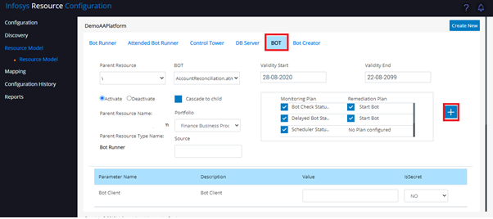

Figure

* A popup will be displayed with three options
  1. Add Parameter
  2. Add Resource
  3. Add Observable - Remediation plan
* Click “Add Parameter” Tab as mentioned in the Figure 23

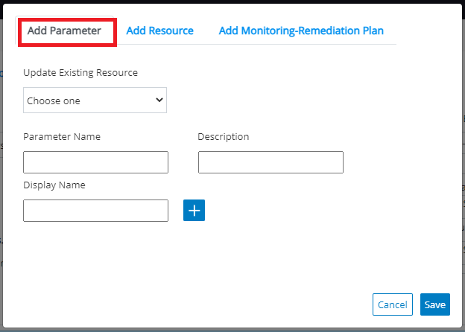

Figure

* Select AccountReconciliation.atmx from the drop down, Update the following fields
  + Parameter Name: BotId
  + Description: Bot Id from Control Tower
  + Display Name: Bot Id
* Click “+” icon and Save as mentioned in the Figure 24

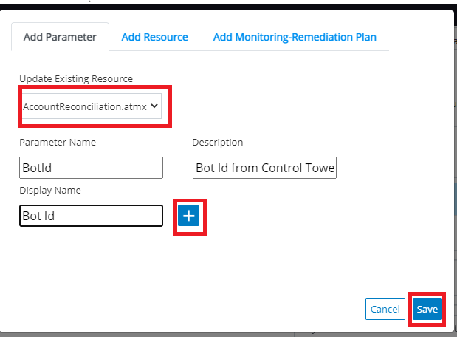

Figure

* Newly added “Bot Id” Parameter displayed in the main Parameter section as mentioned in the Figure 25

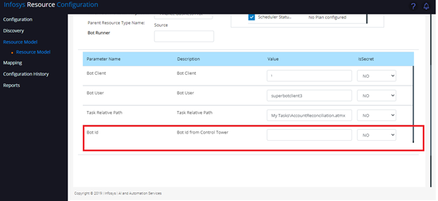

Figure

* User has to update the desired input in the Value section and click Update button to Save the changes as mentioned in the Figure 26

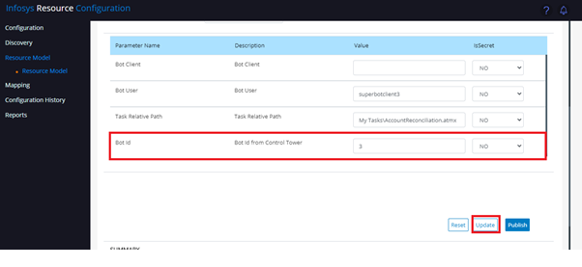

Figure

#### Activate/Deactivate Resources from Resource Screen

* User can Activate/Deactivate a resource and its child resources from Resource Screen.

For Example: If user wants to activate Bot Runner and Its child resources (Bot Runner Services), then perform the following steps

* + Go to Resource screen and Click “Bot Runner” Tab and Click “Activate” Radio Button and Select “Cascade to child” Check Box as mentioned in the Figure 27

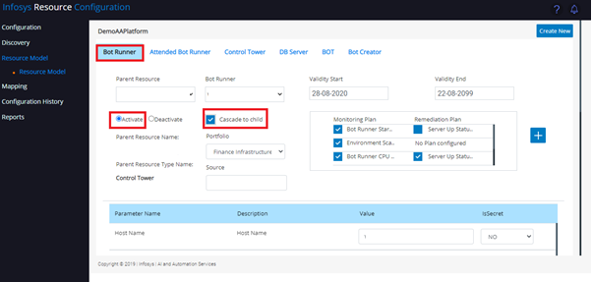

Figure

* + Click Update button to Save the changes as mentioned in the Figure 28

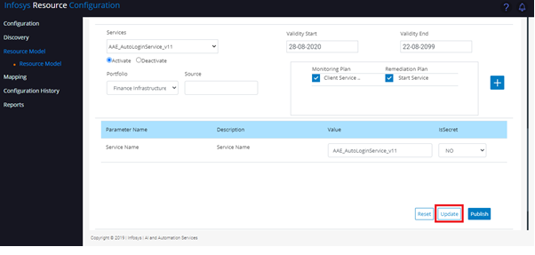

Figure

For Example: If user wants to activate only Bot Runner, then perform the following steps

* + Go to Resource screen and Click “Bot Runner” Tab and Click “Activate” Radio Button option as mentioned in the Figure 29

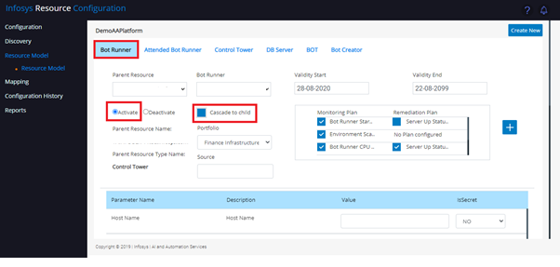

Figure

* + Click Update button to Save the changes as mentioned in the Figure 30

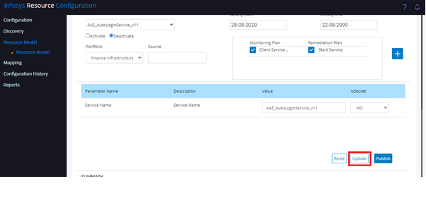

Figure

For Example: If user wants to activate one of the Bot Runner service (AAE_AutoLoginService_v11), then perform the following steps

* + Go to Resource screen and Click “Bot Runner” Tab as mentioned in the Figure 31

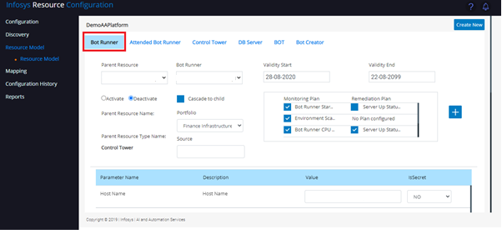

Figure

* + Scroll down to Service section and select “AAE_AutoLoginService_v11” service and Click “Activate” Radio Button and click “Update” button to Save the changes as mentioned in the Figure 28

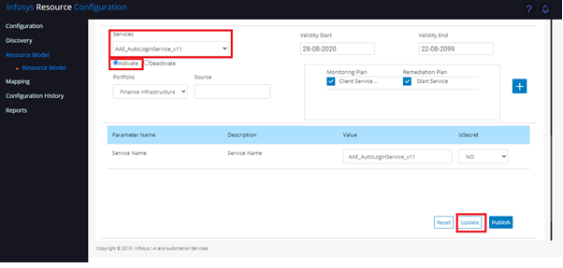

Figure

* User can also to activate/deactivate a resource monitoring by defining a pre-defined validity period.

For Example: If the user wants to deactivate the monitoring process for Bot Runner

* + Go to Resource screen and Click “Bot Runner” Tab and set “Validity End” date as Past date as mentioned in the Figure 33

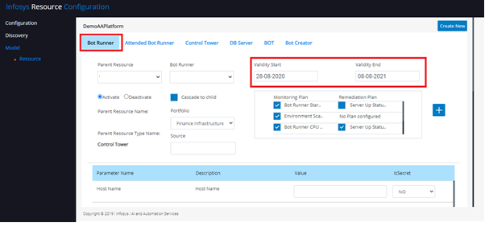

Figure

* + Click Update button to Save as mentioned in the Figure 34

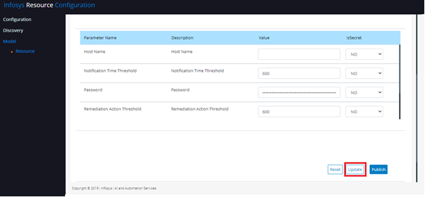

Figure

#### Create a Resource from Resource Screen

* In case if user wants to add a new Resource, then user can add it from Resource screen

For Example: If user created a new Bot (Order Processing) in Automation Anywhere after Discovery process, then user must add the newly created Bot (Order processing) from Resource Screen for Monitoring and Remediation process.

* + Go to Resource screen and Click “Bot” Tab and Click on “+” icon as mentioned in the Figure 35

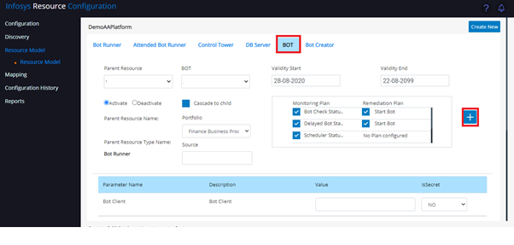

Figure

* + A popup will be displayed with three options

1. Add Parameter
2. Add Resource
3. Add Observable - Remediation plan
   * Click “Add Resource” Tab as mentioned in the Figure 36

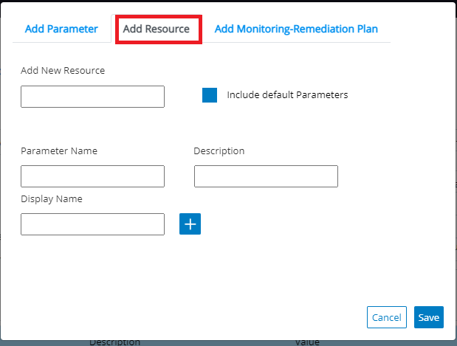

Figure

* + Mentioned “OrderProcessing.atmx” in “Add New Resource” Text Box and Select “Include default Parameters” Check Box and click “Save” Button as mentioned in the Figure 37

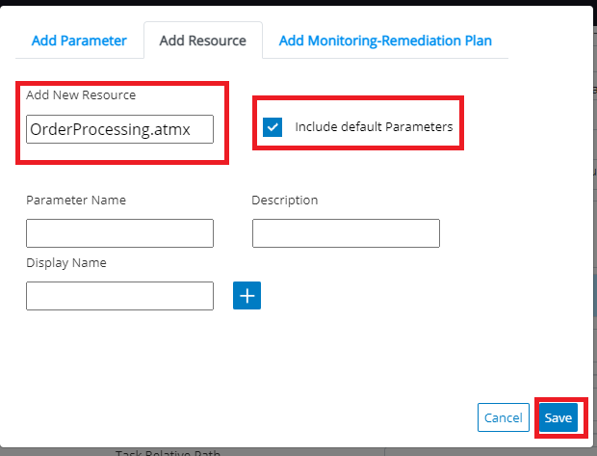

Figure

* + The new Bot “OrderProcessing.atmx” added under “Bot” Tab with default parameters (without values) as mentioned in the Figure 38.

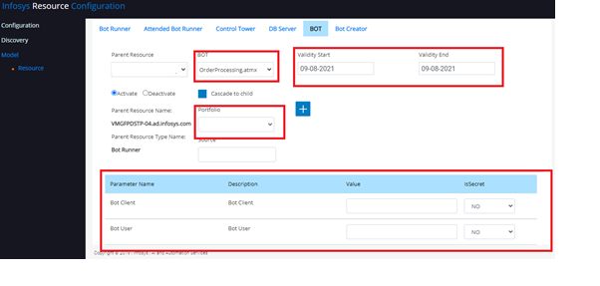

Figure

* + User has to update the validity Period, Portfolio and Parameters value like below for monitoring and remediation process
    - Choose “Activate” Radio Button
    - Validity Start: 09-O8-2021 (Start date for monitoring)
    - Validity End: 31-Dec-2099 (End date for monitoring)
    - Portfolio: Finance Business Process
    - Source: 10.0.0.2 (Bot Runner IP Address)
    - Parameter details:

|  |  |  |  |
| --- | --- | --- | --- |
| **Parameter Name** | **Description** | **Value** | **IsSecret** |
| Bot Client | Bot Client | VM00002 | No |
| Bot User | Bot User | Botclientuser | No |
| Task Relative Path | Task Relative Path | My Tasks\OrderProcessing.atmx | No |

Table

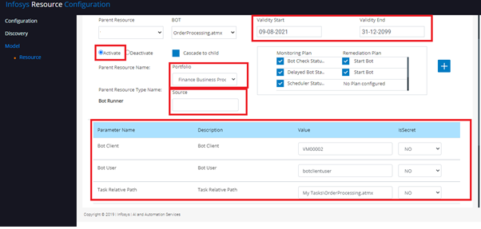

Figure

* After updating the necessary information, User has to click “Update” Button to Save it as mentioned in the Figure 40.

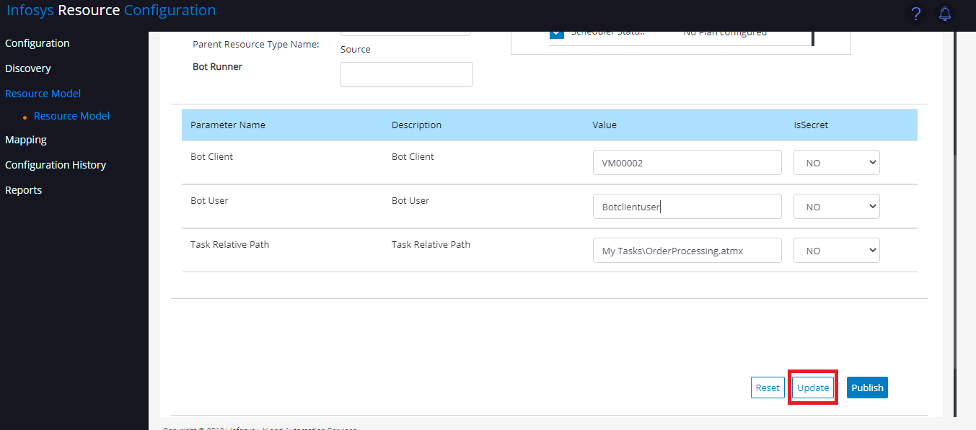

Figure

#### Add/Modify the Monitoring and Remediation Plan

* User can modify the existing Monitoring and Remediation plan from resource screen

For Example: If user wants to perform only monitoring and no remedial action for Account Reconciliation Bot, then user can modify the existing Monitoring and Remediation plan from resource screen

* + Go to Resource screen and Click “BOT” Tab, select “AccountReconciliation.atmx” from the BOT dropdown and unselect “Start Bot” Remediation Plan check box as mentioned in the Figure 41.

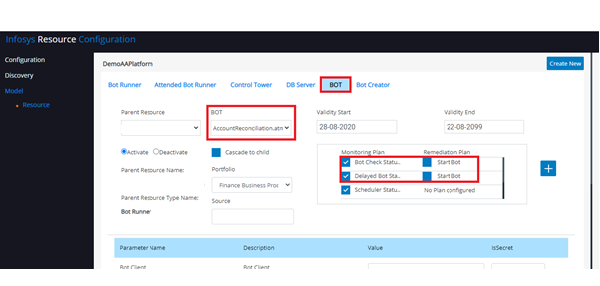

Figure

* + Click Update button to Save as mentioned in the Figure 42

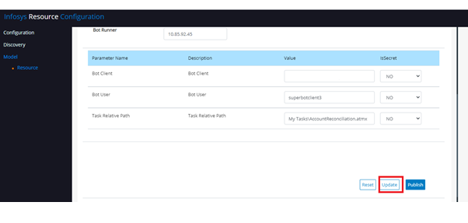

Figure

For Example: If user does not want to monitor “Scheduler Status Check” for Account Reconciliation Bot, then user can modify the existing Monitoring and Remediation plan from resource screen

* + Go to Resource screen and Click “BOT” Tab, select “AccountReconciliation.atmx” from the BOT dropdown and unselect “Scheduler Status Check” Monitoring Plan check box as mentioned in the Figure 43.

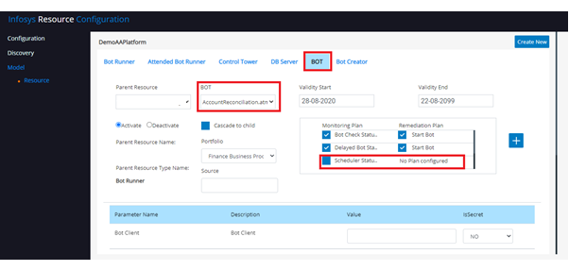

Figure

* + Click Update button to Save as mentioned in the Figure 44

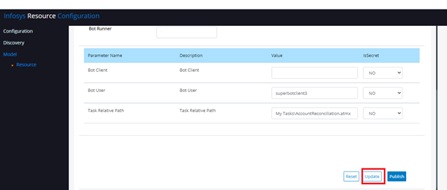

Figure

For Example: If user wants to add “Scheduler Status Check” monitoring plan (It was removed earlier example) for Account Reconciliation Bot, then user can add it from resource screen

* + Go to Resource screen and Click “BOT” Tab, select “AccountReconciliation.atmx” from the BOT dropdown and click “+” icon as mentioned in the Figure 45

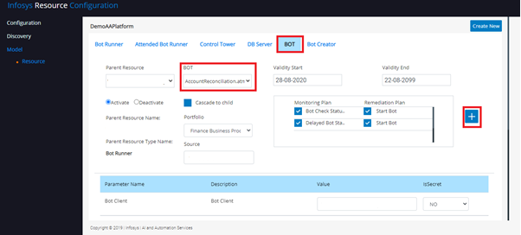

Figure

* A popup will be displayed with three options
  1. Add Parameter
  2. Add Resource
  3. Add Observable - Remediation plan
* Click “Add Observable - Remediation plan” Tab as mentioned in the Figure 46

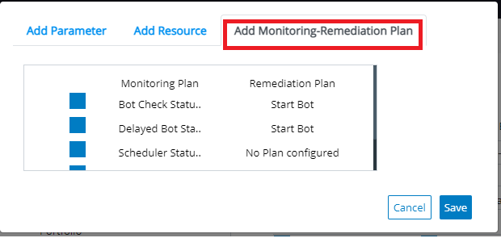

Figure

* + Select “Scheduler Status Check” monitoring plan and click “Save” Button as mentioned in the Figure 47

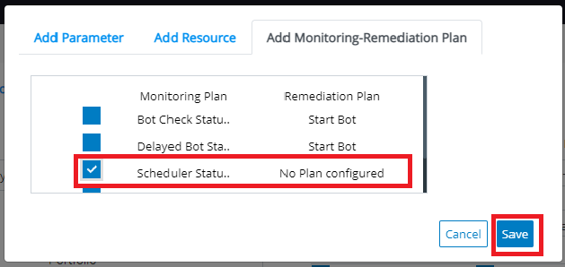

Figure

* + “Scheduler Status Check” monitoring plan added into Account Reconciliation Bot as mentioned in the Figure 48

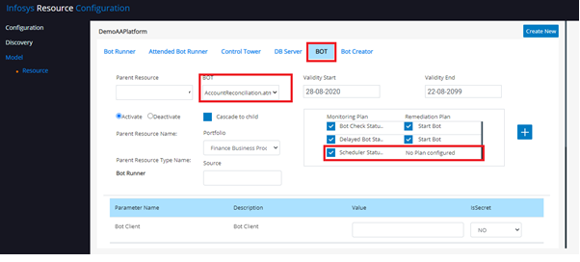

Figure

* + Click Update button to Save as mentioned in the Figure 49

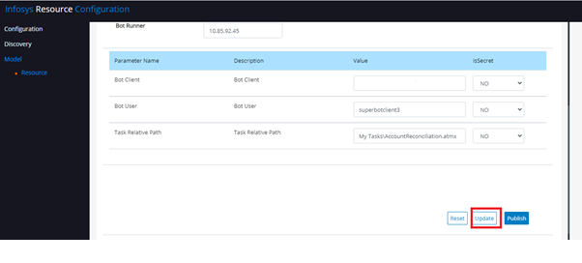

Figure

#### Activate/Deactivate the Resources

* User can Activate/Deactivate the Resources in the platform, by clicking on **Activate/Deactivate** Button

For example: If user wants activate Bot Runner and Bot Runner Services then perform the following steps

* + Go the left side panel and Select **Model** Menuand click **Resource** and select the Automation Anywhere Enterprise (DemoAAPlatform) platform and click “Activate/Deactivate” Button as mentioned in the Figure 50.

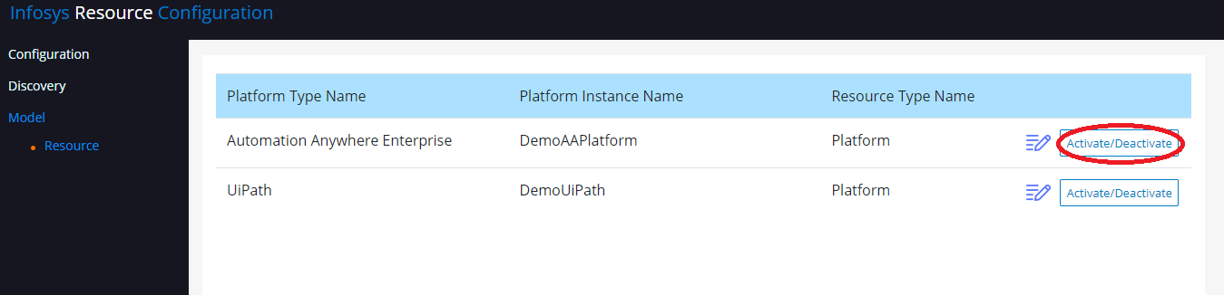

Figure

* + Summary Screen will be displayed as mentioned in the Figure 51

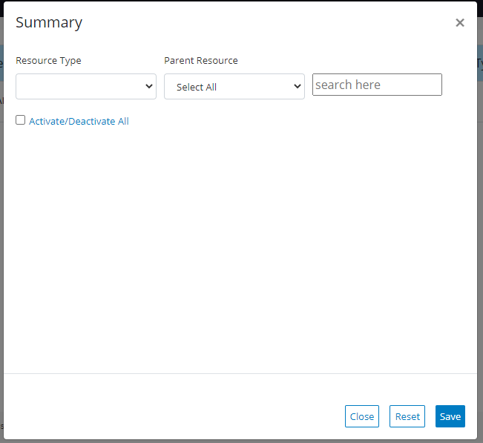

Figure

* + Select “Bot Runner” from Resource Type Drop Down, it will display all the Bot Runner and Bot Runner as mentioned in the Figure 51.

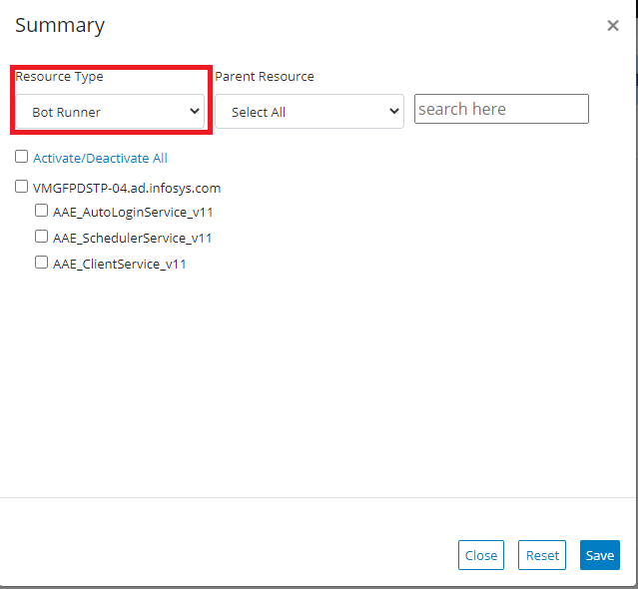

Figure

* + Select “Activate/Deactivate All” Check box, System will automatically select Bot Runner and all Bot Runner Services Check Box for Activation and Click “ Save” button as mentioned in the Figure 53.

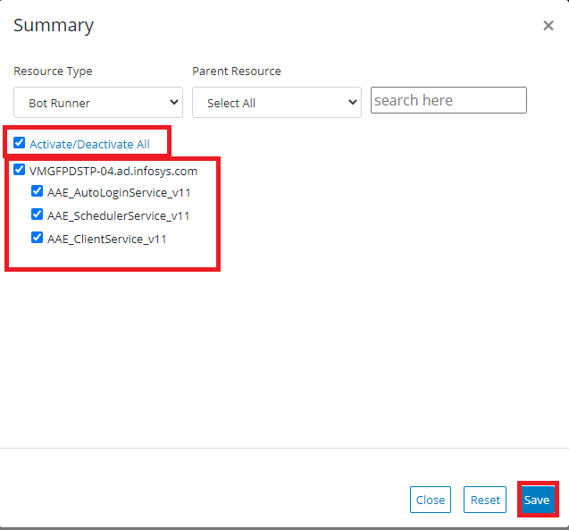

Figure

# RPA Control Center

### RPA Control Center Dashboard

The Infosys RPA Control center provides a cumulative view of the health of the various RPA/IT components. If health is identified as warning or critical, remediation actions can be taken by Infosys Super Bot. For more details, please refer InfosysRPAControlCenterUserGuide.docx

* Open <http://localhost:8080/ops-portal/#/main/clusters>
* Before Discovery no component will be displayed in the Infosys RPA Control Center as mentioned in the figure 54

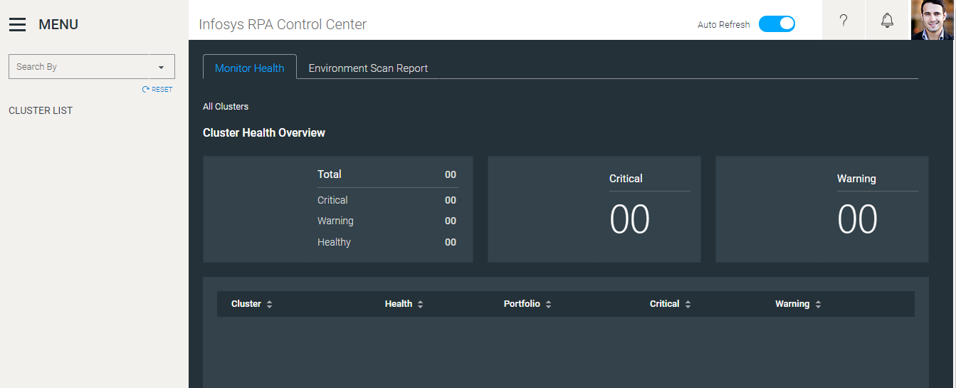

Figure

* After performing the following action by the user as mentioned in section 2
  + Auto Configuration for Automation Anywhere as mentioned in the section 2.1.1.1
  + Map the portfolio to the discovered resources as mentioned in the section 2.1.2.3
  + Activate the desired resources as mentioned in the section 2.1.2.6 or 2.1.2.9
* For example: User mapped the following portfolios,
  + Finance Infrastructure
    - For all the Infrastructure components such as Control Tower, Control Tower Windows Service, Bot Runner, Bot Runner Windows Services, Database Server, Database windows services, Bot Creator, Bot Creator windows Services.
  + Finance Business Process
    - For all the Bot / Process, example: Account Reconciliation Bot, Order Entry Bot, Order Processing Bot, Worker Order Bot
* The Infosys RPA Control Center will display the portfolio information’s as mentioned in the Figure 55

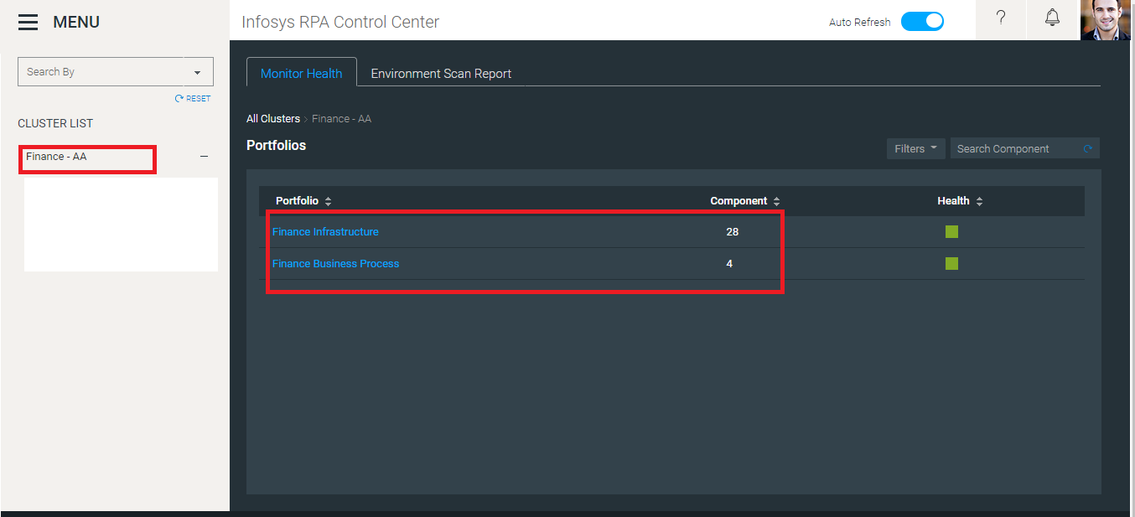

Figure

* After starting the monitoring process in the SuperBot (Refer the SuperBot_Installation_Document, Section 7.3 (Setting up SuperBot HealthCheck Task) and Step # 12), Dashboard will start display the health of the components like below
  + All the infrastructure components are displayed under Finance Infrastructure Portfolio as mentioned in the Figure 56

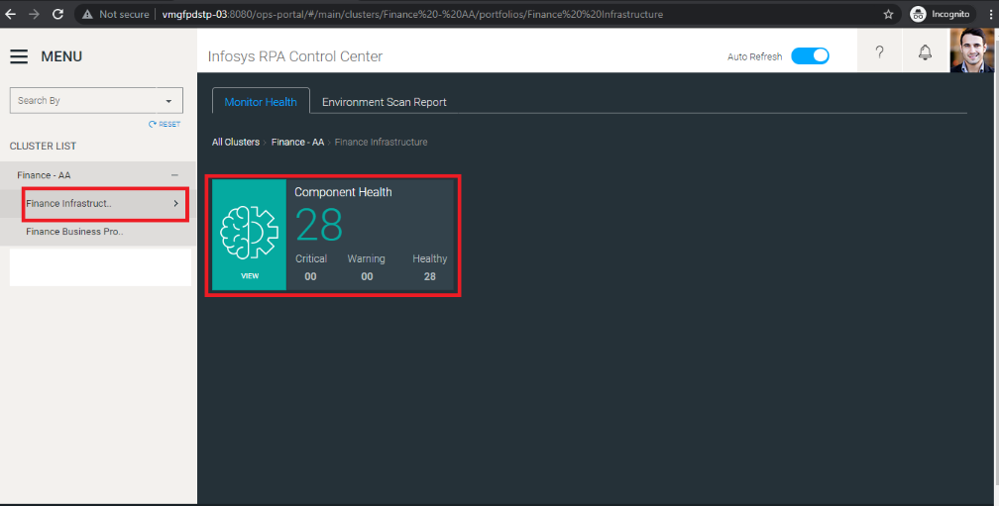

Figure

* + All the Bot components are displayed under Finance Business Process Portfolio as mentioned in the Figure 57

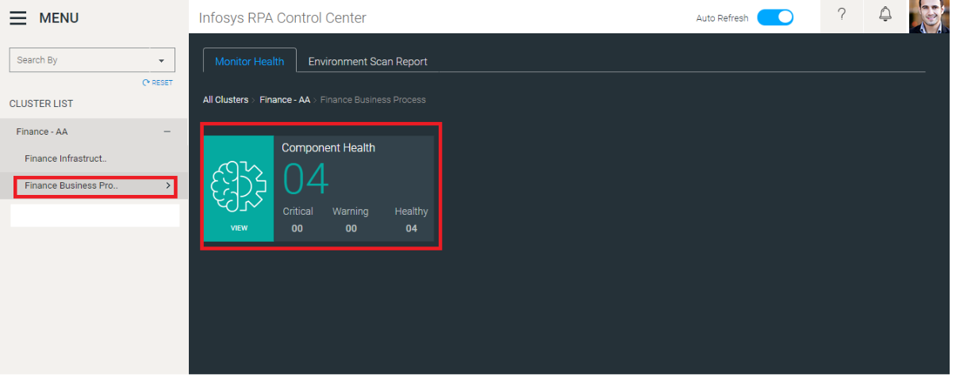

Figure

* + If the user clicks the Component Health card, it will display health of the component as mentioned in the Figure 58

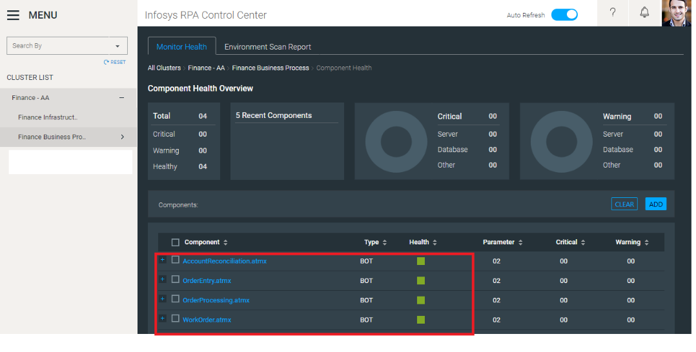

Figure

* + If the user expands any of the components it displays the details of the components as mentioned in the Figure 59

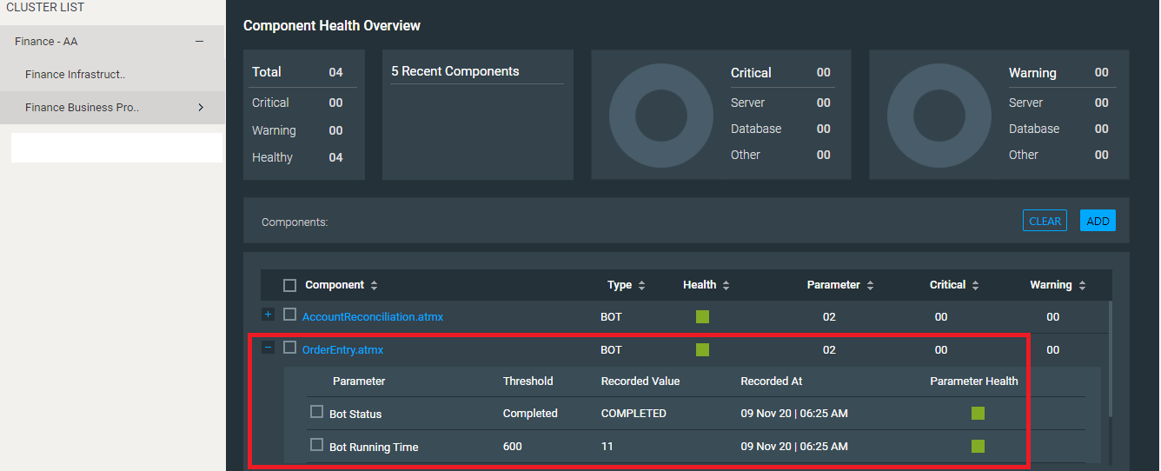

Figure